Appendix 1. Taxon and gene sampling for phylogenetic analysis of plethodontid salamanders. Letters A, B, C, D, E, F, and G denote geographically and genetically distinct lineages of named species identified in published phylogeographic analyses. Data sources: 1. Chippindale et al. (2004); 2. Vieites et al. (2007); 3. Mahoney (2001); 4. Mueller et al. (2004); 5. Min et al. (2005); 6. Jockusch et al. (2001); 7. Wiens et al. (2006b); 8. Kozak et al. (2006a); 9. Kozak et al. (2005); 10. Kozak et al. (2006b); 11. Bonett and Chippindale (2004); 12. Wiens et al. (2003); 13. This study. GenBank accession numbers have been requested for all new sequences generated in this study and will be included upon acceptance.
Taxon | RAG-1 | POMC | BDNF | ND4 | Cyt-b | ND2
Amphiuma tridactylum | 1 | 2 | 2 | - | - | -
Rhyacotriton variegatus | 6 | 2 | 2 | - | - | -
Aneides aeneus | 1 | 2 | 2 | 1 | 1 | -
Aneides lugubris | 6 | 2 | 2 | 1 | 1 | -
Aneides hardii | 2 | 2 | 2 | 4 | 4 | 4
Aneides ferreus | 2 | 2 | 2 | 3 | - | -
Aneides flavipunctatus | 2 | 2 | 2 | 4 | 4 | 4
Hydromantes shastae | 2 | 2 | 2 | - | - | -
Hydromantes platycephalus | 2 | 2 | 2 | - | - | -
Hydromantes italicus | 2 | 2 | 2 | 4 | 4 | 4
Hydromantes brunus | 2 | 2 | 2 | 4 | 4 | 4
Karsenia koreana | 5 | 2 | 2 | - | - | -
Ensatina eschscholtzii | 1 | 2 | 2 | 1 | 1 | -
Ensatina eschscholtzii | - | - | - | 1 | 1 | -
Batrachoseps major | 2 | 2 | 2 | 1 | 1 | -
Batrachoseps wrighti | - | - | - | - | 6 | -
Batrachoseps campi | - | - | - | - | 6 | -
Batrachoseps attenuatus | - | - | - | 4 | 6 | 4
Batrachoseps nigriventris | - | - | - | - | 6 | -
Batrachoseps gregarius | - | - | - | - | 6 | -
Batrachoseps simatus | - | - | - | - | 6 | -
Batrachoseps stebbinsi | - | - | - | - | 6 | -
Batrachoseps gavilensis | - | - | - | - | 6 | -
Batrachoseps luciae | - | - | - | - | 6 | -
Batrachoseps incognitus | - | - | - | - | 6 | -
Batrachoseps minor | - | - | - | - | 6 | -
Batrachoseps gabrieli | - | - | - | - | 6 | -
Batrachoseps diabolicus | - | - | - | - | 6 | -
Batrachoseps regius | - | - | - | - | 6 | -
Batrachoseps kawia | - | - | - | - | 6 | -
Batrachoseps relictus | - | - | - | - | 6 | -
Bolitoglossa helmrichi | 1 | - | - | 1 | 1 | -
Nyctanolis pernix | 1 | - | - | 1 | 1 | -
Pseudoeurycea rex | 1 | - | - | 1 | 1 | -
Plethodon vehiculum | 7 | - | - | 7 | 7 | 8
Plethodon dunni | 7 | - | - | 7 | 7 | 8
Plethodon idahoensis | 7 | - | - | 7 | 7 | 8
Plethodon neomexicanus | 7 | - | - | 7 | 7 | 8
Plethodon vandykei | 7 | 2 | 2 | 7 | 7 | 8
Plethodon albagula | 7 | - | - | 7 | 7 | 8
Plethodon amplus | 7 | - | - | 7 | 7 | 8
Plethodon angusticlavius | 7 | - | - | 7 | 7 | 8
Plethodon aureolus | 7 | - | - | 7 | 7 | 8
Plethodon caddoensis | 7 | - | - | 7 | 7 | 8
Plethodon chattahoochee | 7 | - | - | 7 | 7 | 8
Plethodon cheoah | 7 | - | - | 7 | 7 | 8
Plethodon chlorobryonis | 7 | - | - | 7 | 7 | 8
Plethodon cinereus | 7 | - | - | 7 | 7 | 8
Plethodon cylindraceus | 7 | - | - | 7 | 7 | 8
Plethodon dorsalis | 7 | - | - | 7 | 7 | 8
Plethodon dunni | 7 | - | - | 7 | 7 | 8
Plethodon electromorphus | 7 | - | - | 7 | 7 | 8
Plethodon elongatus | 7 | 2 | 2 | 7 | 7 | 8
Plethodon fourchensis | 7 | 2 | 2 | 7 | 7 | 8
Plethodon glutinosus | 7 | - | - | 7 | 7 | 8
Plethodon grobmani | 7 | - | - | 7 | 7 | 8
Plethodon hoffmani | 7 | 2 | 2 | 7 | 7 | 8
Plethodon hubrichti | 7 | - | - | 7 | 7 | 8
Plethodon jordani | 7 | 2 | 2 | 7 | 7 | 8
Plethodon kentucki | 7 | - | - | 7 | 7 | 8
Plethodon kiamichi | 7 | - | - | 7 | 7 | 8
Plethodon kisatchie | 7 | - | - | 7 | 7 | 8
Plethodon larselli | 7 | 2 | 2 | 7 | 7 | 8
Plethodon meridianus | 7 | - | - | 7 | 7 | 8
Plethodon metcalfi | 7 | - | - | 7 | 7 | 8
Plethodon mississippi | 7 | - | - | 7 | 7 | 8
Plethodon montanus | 7 | - | - | 7 | 7 | 8
Plethodon nettingi | 7 | - | - | 7 | 7 | 8
Plethodon ocmulgee | 7 | - | - | 7 | 7 | 8
Plethodon ouachitae | 7 | 2 | 2 | 7 | 7 | 8
Plethodon petraeus | 7 | - | - | 7 | 7 | 8
Plethodon punctatus | 7 | - | - | 7 | 7 | 8
Plethodon richmondi | 7 | - | - | 7 | 7 | 8
Plethodon savannah | 7 | - | - | 7 | 7 | 8
Plethodon sequoyah | 7 | - | - | 7 | 7 | 8
Plethodon serratus | 7 | 2 | 2 | 7 | 7 | 8
Plethodon shenandoah | 7 | - | - | 7 | 7 | 8
Plethodon shermani | 7 | - | - | 7 | 7 | 8
Plethodon teyahalee | 7 | 2 | 2 | 7 | 7 | 8
Plethodon variolatus | 7 | - | - | 7 | 7 | 8
Plethodon ventralis | 7 | - | - | 7 | 7 | 8
Plethodon virginia | 7 | - | - | 7 | 7 | 8
Plethodon websteri | 7 | - | - | 7 | 7 | 8
Plethodon wehrlei | 7 | - | - | 7 | 7 | 8
Plethodon welleri | 7 | - | - | 7 | 7 | 8
Plethodon yonahlossee | 7 | 2 | 2 | 7 | 7 | 8
Phaeognathus hubrichti | 1 | 2 | 2 | 1 | 1 | 9
Desmognathus wrighti A | 13 | - | - | 13 | - | 9
Desmognathus wrighti B | 13 | - | - | 13 | 13 | 9
Desmognathus aeneus | 1 | - | - | 1 | 1 | 9
Desmognathus imitator | 13 | - | - | 13 | - | 9
Desmognathus quadramaculatus A | 13 | - | - | 13 | - | 9
Desmognathus marmoratus B | 13 | - | - | 13 | - | 9
Desmognathus quadramaculatus C | 13 | - | - | 13 | - | 9
Desmognathus quadramaculatus D | 13 | - | - | 13 | - | 9
Desmognathus marmoratus C | 13 | - | - | 13 | - | 9
Desmognathus quadramaculatus E | 13 | - | - | 13 | - | 9
Desmognathus folkertsi | 13 | - | - | - | - | 9
Desmognathus brimleyorum | 1 | 2 | 2 | 1 | 1 | 9
Desmognathus monticola B | 13 | - | - | 13 | 1 | 9
Desmognathus monticola A | 13 | - | - | 13 | - | 9
Desmognathus welteri | 13 | - | - | 13 | - | 9
Desmognathus ocoee A | 13 | - | - | 13 | 13 | 9
Desmognathus ocoee F | 13 | - | - | 13 | 13 | 9
Desmognathus ocoee E | 13 | - | - | 13 | - | 9
Desmognathus ocoee D | 13 | - | - | 13 | - | 9
Desmognathus ocoee C | 13 | - | - | - | 13 | 9
Desmognathus ocoee B | 13 | - | - | 13 | - | 9
Desmognathus ocoee G | 13 | - | - | 13 | 13 | 9
Desmognathus apalachicolae | 13 | - | - | 13 | - | 9
Desmognathus orestes | 13 | - | - | 13 | 13 | 9
Desmognathus ochrophaeus | 13 | - | - | 13 | - | 9
Desmognathus carolinensis | 13 | - | - | 13 | - | 9
Desmognathus auriculatus | 13 | - | - | 13 | - | 9
Desmognathus conanti A | 13 | - | - | - | - | 9
Desmognathus conanti B | 13 | - | - | 13 | - | 9
Desmognathus conanti C | 13 | - | - | 13 | - | 9
Desmognathus conanti D | 13 | - | - | 13 | 13 | 9
Desmognathus santeetlah | - | - | - | 13 | - | 9
Desmognathus fuscus-carolinensis | 13 | - | - | 13 | 13 | 9
Desmognathus fuscus A | 13 | - | - | 13 | - | 9
Desmognathus fuscus B | 13 | 2 | 2 | 13 | - | 9
Hemidactylium scutatum | 1 | 2 | 2 | 1 | 1 | 13
Stereochilus marginatus | 1 | - | - | 1 | 1 | 13
Gyrinophilus porphyriticus porphyriticus NY | 13 | - | - | 13 | 13 | 13
Gyrinophilus porphyriticus porphyriticus KY | 13 | - | - | 13 | 13 | 13
Gyrinophilus porphyriticus dunni NC | 13 | - | - | 13 | 13 | 13
Gyrinophilus porphyriticus dunni SC | 13 | - | - | 13 | 13 | 13
Gyrinophilus porphyriticus dunni AL | - | - | - | 13 | 13 | 13
Gyrinophilus porphyriticus danielsi NC | 13 | - | - | 13 | 13 | 13
Gyrinophilus porphyriticus danielsi NC | - | 2 | 2 | 13 | 13 | 13
Pseudotriton ruber ruber SC | 13 | - | - | 13 | 13 | 13
Pseudotriton ruber ruber KY-1 | 13 | - | - | 13 | 13 | 13
Pseudotriton ruber ruber KY-2 | 13 | - | - | 13 | 13 | 13
Pseudotriton ruber ruber VA-1 | 13 | - | - | 13 | 13 | 13
Pseudotriton ruber ruber VA-1 | 13 | - | - | 13 | 13 | 13
Pseudotriton ruber schencki NC-1 | 13 | 2 | 2 | 13 | 13 | 13
Pseudotriton ruber nitidus | 13 | - | - | 13 | 13 | 13
Pseudotriton ruber viscoi | 13 | - | - | 13 | 13 | 13
Pseudotriton ruber schencki TN | 13 | - | - | 13 | 13 | 13
Pseudotriton ruber schencki NC-2 | 13 | - | - | 13 | 13 | 13
Pseudotriton ruber ruber AL | 13 | - | - | 13 | 13 | 13
Pseudotriton ruber viscoi AL | 13 | - | - | 13 | 13 | 13
Pseudotriton ruber viscoi FL | 13 | - | - | 13 | 13 | -
Pseudotriton montanus diastictus KY | 13 | - | - | - | 13 | 13
Pseudotriton montanus floridanus | 13 | - | - | - | 13 | 13
Eurycea bislineata A | 13 | 2 | 2 | 13 | - | 10
Eurycea cirrigera C TN-1 | 13 | - | - | 13 | 13 | 10
Eurycea cirrigera C TN-2 | 13 | - | - | - | - | 10
Eurycea cirrigera D KY-1 | 13 | - | - | 13 | 13 | 10
Eurycea cirrigera D KY-2 | 13 | - | - | - | - | 10
Eurycea wilderae-cirrigera E WV | 13 | - | - | 13 | - | 10
Eurycea wilderae-cirrigera J NC | 13 | - | - | 13 | 13 | 10
Eurycea wilderae M NC | 13 | - | - | 13 |  | 10
Eurycea wilderae M NC | 13 | - | - | 13 | 13 | 10
Eurycea cirrigera L MS | 13 | - | - | 13 | 13 | 10
Eurycea cirrigera L GA | 13 | - | - | 13 | 13 | 10
Eurycea aquatica | 13 | - | - | 13 | 13 | 10
Eurycea aquatica | 13 | - | - | 13 | - | 10
Eurycea junaluska NC | 13 | - | - | 13 | 13 | 10
Eurycea junaluska TN | 13 | - | - | 13 | 13 | 10
Eurycea longicauda longicauda KY | 13 | - | - | 13 | 13 | 13
Eurycea longicauda longicauda TN | 13 | - | - | 13 | 13 | 13
Eurycea longicauda melanopleura MO | 13 | - | - | 13 | 13 | 13
Eurycea lucifuga TN | 13 | - | - | 13 | 13 | 13
Eurycea guttolineata SC | 13 | - | - | 13 | - | 10
Eurycea guttolineata MS | 13 | - | - | 13 | - | 13
Eurycea guttolineata NC | 13 | - | - | 13 | - | 13
Eurycea quadridigitata MS | 13 | - | - | 13 | - | 10
Eurycea quadridigitata SC | 13 | - | - | - | - | 13
Eurycea multiplicata | 1 | - | - | 1 | 1 | -
Eurycea spelaeus | - | - | - | 11 | 11 | -
Eurycea tynerensis | - | - | - | 11 | 11 | -
Eurycea neotenes | 1 | - | - | 1 | 12 | -
Eurycea tonkawae | - | - | - | - | 12 | -
Eurycea chisholmensis | - | - | - | - | 12 | -
Eurycea naufragia | - | - | - | - | 12 | -
Eurycea rathbuni | - | - | - | - | 12 | -
Eurycea nana | - | - | - | - | 12 | -
Eurycea tridentifera | - | - | - | - | 12 | -
Eurycea latitans | - | - | - | - | 12 | -
Eurycea sosorum | - | - | - | - | 12 | -
Eurycea sp. nov. (Comal Springs) | - | - | - | - | 12 | -
Eurycea pterophila | - | - | - | - | 12 | -
Eurycea troglodytes | - | - | - | - | 12 | -

Appendix 2. (A) Maximum-likelihood phylogram obtained from the combined analysis of the three nuclear genes (RAG-1, BDNF, and POMC); the tree has a ln-likelihood of
-17993.182957. (B) Maximum-likelihood phylogram obtained from the combined analysis of the three mitochondrial genes (cyt-b, ND2, and ND4); the tree has a ln-likelihood of -90034.329079. The proportion of times each node was resolved among 200 bootstrap replicates is shown under the branches. Bootstrap proportions <50% are not shown. Support values from some near-terminal branches have been omitted for illustrative purposes. Separate analyses of each of the six genes produced congruent phylogenetic estimates (conflicting phylogenetic relationship generally received <50% bootstrap support, except for the placement of P. serratus in the mtDNA vs. nDNA trees). Phylograms from each of separate-gene analyses are available from the authors upon request.

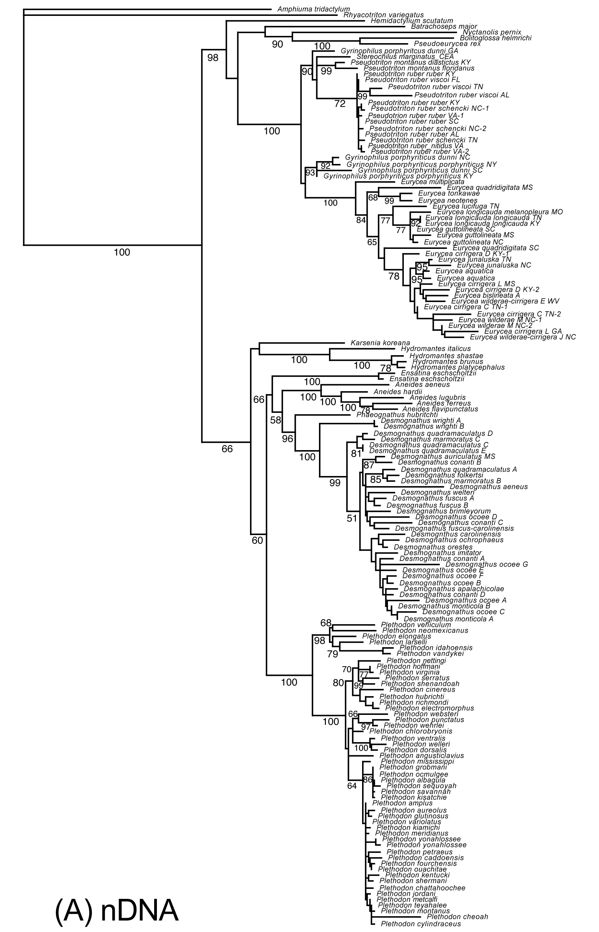
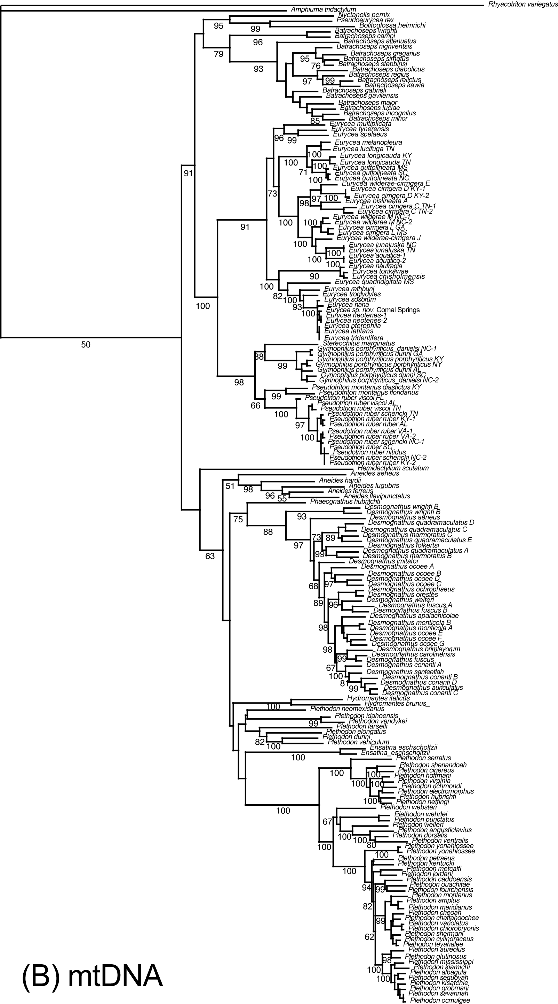
Appendix 3. Mean adult body-sizes (SVL) and sample sizes (n) for all species included in the morphological analyses. Data sources: 1. Carr (1996); 2. Wiens and Hoverman (2008); 3. Highton and Peabody (2000); 4. Titus and Larson (1996); 5. Rose and Bush (1963); 6. Chippindale et al. (2000); 7. Potter and Sweet (1981); 8. Jockusch et al. (2001); 9. Hillis et al. (2001); 10. this study; 11. Stebbins (1954); 12. Gorman (1954); 13. Bruce (1971); 14. Brodie (1970); 15. Anthony (1993); 16. Ollivier and Welsh (2003); 17. Wilson et al. (2002); 18. Herbeck et al. (2000); 19. Peacock et al. (1973); 20. Bruce (1972); 21. Bruce (1978); 22. Adams and Church (2008). Letters A, B, C, D, E, F, or G denote geographically and genetically distinct lineages of named species identified in published phylogeographic analyses. Body sizes derived from more than a single source represent an average of the mean values reported in each study. n/a denotes SVL values for which no sample size was reported in the original source. Note that morphometric data for Aneides vagrans were used for the species Aneides ferreus on the phylogeny (these two taxa represent morphologically cryptic species; Jackman 1999).

Species | Source | n | SVL | Clade
Plethodon albagula | 1, 2 | 65 | 67.6 | Eastern Plethodon
Plethodon amplus | 3 | n/a | 61 | Eastern Plethodon
Plethodon angusticlavius | 2 | 3 | 43.4 | Eastern Plethodon
Plethodon aureolus | 1 | 47 | 55.5 | Eastern Plethodon
Plethodon caddoensis | 15 | 22 | 43.7 | Eastern Plethodon
Plethodon chattahoochee | 1 | 101 | 61.3 | Eastern Plethodon
Plethodon cheoah | 3 | n/a | 52.5 | Eastern Plethodon
Plethodon chlorobryonis | 1, 2 | 31 | 52.7 | Eastern Plethodon
Plethodon cinereus | 2 | 10 | 45.3 | Eastern Plethodon
Plethodon cylindraceus | 1, 2 | 76 | 71 | Eastern Plethodon
Plethodon dorsalis | 2 | 6 | 40.9 | Eastern Plethodon
Plethodon glutinosus | 1, 2 | 242 | 68.5 | Eastern Plethodon
Plethodon grobmani | 1, 2 | 48 | 58.2 | Eastern Plethodon
Plethodon hoffmani | 2 | 10 | 48.6 | Eastern Plethodon
Plethodon hubrichti | 2 | 10 | 53.8 | Eastern Plethodon
Plethodon jordani | 22 | 4173 | 53.9 | Eastern Plethodon
Plethodon kentucki | 1, 2 | 64 | 59.8 | Eastern Plethodon
Plethodon kiamichi | 1 | 52 | 66.7 | Eastern Plethodon
Plethodon meridianus | 3 | n/a | 61.5 | Eastern Plethodon
Plethodon metcalfi | 22 | 4016 | 54.8 | Eastern Plethodon
Plethodon mississippi | 1, 2 | 55 | 64 | Eastern Plethodon
Plethodon montanus | 3 | n/a | 55 | Eastern Plethodon
Plethodon nettingi | 2 | 10 | 45.1 | Eastern Plethodon
Plethodon ocmulgee | 1 | 20 | 59.3 | Eastern Plethodon
Plethodon ouachitae | 15 | 26 | 55.2 | Eastern Plethodon
Plethodon petraeus | 1 | 41 | 70.7 | Eastern Plethodon
Plethodon punctatus | 2 | 10 | 64.1 | Eastern Plethodon
Plethodon richmondi | 2 | 10 | 52.5 | Eastern Plethodon
Plethodon sequoyah | 1, 2 | 30 | 64.7 | Eastern Plethodon
Plethodon serratus | 18 | 228 | 38.5 | Eastern Plethodon
Plethodon shenandoah | 2 | 5 | 46.9 | Eastern Plethodon
Plethodon shermani | 22 | 2333 | 55.1 | Eastern Plethodon
Plethodon teyahalee | 1, 2 | 41 | 69.7 | Eastern Plethodon
Plethodon variolatus | 1 | 76 | 58.3 | Eastern Plethodon
Plethodon ventralis | 2 | 10 | 42 | Eastern Plethodon
Plethodon wehrlei | 2 | 10 | 57.5 | Eastern Plethodon
Plethodon welleri | 2 | 10 | 42.7 | Eastern Plethodon
Plethodon yonahlossee | 1, 2 | 25 | 84.5 | Eastern Plethodon
Plethodon dunni | 2, 10 | 9 | 58.2 | Western Plethodon
Plethodon elongatus | 16 | 267 | 53.8 | Western Plethodon
Plethodon idahoensis | 2, 17 | 2, n/a | 44.1 | Western Plethodon
Plethodon neomexicanus | 2 | 10 | 62.1 | Western Plethodon
Plethodon vandykei | 14 | 48 | 53.0 | Western Plethodon
Plethodon vehiculum | 19 | 352 | 47.2 | Western Plethodon
Desmognathus aeneus | 2, 4 | 12 | 25.9 | Desmognathus
Desmognathus apalachicolae | 4 | n/a | 42.7 | Desmognathus
Desmognathus auriculatus | 2, 4 | 18 | 53.9 | Desmognathus
Desmognathus brimleyorum | 4 | 25 | 76.5 | Desmognathus
Desmognathus carolinensis | 4 | 12 | 45.6 | Desmognathus
Desmognathus conanti D | 4 | 24 | 56.8 | Desmognathus
Desmognathus folkertsi | 4 | 18 | 71.4 | Desmognathus
Desmognathus fuscus A | 4 | 5 | 61.8 | Desmognathus
Desmognathus fuscus B | 2, 4 | 43 | 56.7 | Desmognathus
Desmognathus imitator | 2, 4 | 18 | 44.5 | Desmognathus
Desmognathus marmoratus B | 4 | 20 | 82.8 | Desmognathus
Desmognathus marmoratus C | 4 | 20 | 77.1 | Desmognathus
Desmognathus monticola | 4, | 33 | 61.8 | Desmognathus
Desmognathus ochrophaeus | 2, 4 | 12 | 40.4 | Desmognathus
Desmognathus ocoee A | 4 | 5 | 42.9 | Desmognathus
Desmognathus ocoee C | 4 | 10 | 44.6 | Desmognathus
Desmognathus ocoee F | 4 | 7 | 40.1 | Desmognathus
Desmognathus ocoee G | 4 | 7 | 46.2 | Desmognathus
Desmognathus orestes | 4 | 10 | 38.9 | Desmognathus
Desmognathus quadramaculatus E | 4 | 19 | 69.4 | Desmognathus
Desmognathus quadramaculatus A | 4 | 6 | 70.2 | Desmognathus
Desmognathus santeetlah | 4 | 10 | 45.2 | Desmognathus
Desmognathus welteri | 2, 4 | 21 | 66.6 | Desmognathus
Desmognathus wrighti | 2, 4 | 15 | 27.8 | Desmognathus
Phaeognathus hubrichti | 2 | 5 | 108 | Desmognathus
Eurycea aquatica | 5 | n/a | 36 | Spelerpinae
Eurycea bislineata A | 2, 10 | 10 | 40.4 | Spelerpinae
Eurycea chisholmensis | 6 | 7 | 32.9 | Spelerpinae
Eurycea cirrigera C | 10 | 36 | 37 | Spelerpinae
Eurycea cirrigera D | 10 | 26 | 37.3 | Spelerpinae
Eurycea cirrigera L | 10 | 15 | 31.8 | Spelerpinae
Eurycea guttolineata | 10 | 6 | 51 | Spelerpinae
Eurycea junaluska | 2 | 7 | 43.5 | Spelerpinae
Eurycea latitans | 6 | 4 | 36 | Spelerpinae
Eurycea longicauda | 2 | 10 | 59.1 | Spelerpinae
Eurycea lucifuga | 2 | 9 | 62.9 | Spelerpinae
Eurycea multiplicata | 2 | 10 | 41 | Spelerpinae
Eurycea nana | 6 | 5 | 26 | Spelerpinae
Eurycea naufragia | 6 | 13 | 29 | Spelerpinae
Eurycea neotenes | 2 | 6 | 35 | Spelerpinae
Eurycea quadridigitata | 2 | 10 | 30.2 | Spelerpinae
Eurycea rathbuni | 7 | 10 | 54.3 | Spelerpinae
Eurycea sosorum | 6 | 23 | 29.2 | Spelerpinae
Eurycea sp. nov. (Comal Springs) | 6 | 19 | 27.8 | Spelerpinae
Eurycea spelaeus | 2 | 1 | 50.7 | Spelerpinae
Eurycea tonkawae | 6 | 29 | 30.5 | Spelerpinae
Eurycea tridentifera | 6 | 4 | 37.6 | Spelerpinae
Eurycea tynerensis | 2 | 10 | 33.3 | Spelerpinae
Eurycea wilderae J | 10 | 11 | 32 | Spelerpinae
Eurycea wilderae M | 2, 10 | 17 | 35.2 | Spelerpinae
Gyrinophilus porphyriticus | 2, 20 | 282 | 80.2 | Spelerpinae
Hemidactylium scutatum | 2 | 10 | 40.2 | Spelerpinae
Pseudotriton montanus | 2 | 10 | 75 | Spelerpinae
Pseudotriton ruber | 2, 21 | 226 | 68.3 | Spelerpinae
Stereochilus marginatus | 13 | 79 | 41.3 | Spelerpinae
Aneides aeneus | 2 | 10 | 49.8 | Aneides
Aneides vagrans (ferreus) | 2 | 5 | 68.3 | Aneides
Aneides flavipunctatus | 2 | 5 | 65.3 | Aneides
Aneides hardii | 2 | 5 | 54 | Aneides
Aneides lugubris | 2 | 7 | 79.3 | Aneides
Batrachoseps attenuatus | 2 | 10 | 44.6 | Batrachoseps
Batrachoseps gavilensis | 8 | 10 | 43.5 | Batrachoseps
Batrachoseps incognitus | 8 | 10 | 42.3 | Batrachoseps
Batrachoseps luciae | 8 | 10 | 38.8 | Batrachoseps
Batrachoseps major | 2 | 5 | 53.3 | Batrachoseps
Batrachoseps minor | 8 | 10 | 30.6 | Batrachoseps
Batrachoseps nigriventris | 8 | 10 | 37.5 | Batrachoseps
Batrachoseps wrighti | 2 | 1 | 44.6 | Batrachoseps
Ensatina eschscholtzii | 2 | 3 | 64.5 | Ensatina
Hydromantes brunus | 11 | n/a | 57.3 | Hydromantes
Hydromantes platycephalus | 2 | 3 | 52.8 | Hydromantes
Hydromantes shastae | 12 | n/a | 54 | Hydromantes

Literature Cited (Appendix 3)
Adams, D. C, and J. O. Church. 2008. Amphibians do not follow Bergmann’s rule. Evolution 62:413--420.
Anthony, C. D. 1993. Recognition of conspecific odors by Plethodon caddoensis and P. ouachitae. Copeia 1993:1028--1033.
Brodie, E. D., Jr. 1970. Western salamanders of the genus Plethodon: systematics and geographic variation. Herpetologica 26:468--516.
Bruce, R. C. 1971. Life cycle and population structure of the salamander Stereochilus marginatus in North Carolina. Copeia 1971:234-246.
Bruce, R. C. 1972. Variation in the life cycle of the salamander Gyrinophilus porphyriticus. Herpetologica 28:230--245.
Bruce, R. C. 1978. Reproductive biology of the salamander Pseudotriton ruber in the southern Blue Ridge Mountains. Copeia 1978:417--423.
Carr, D. E. 1996. Morphological variation among species and populations of salamanders in the Plethodon glutinosus complex. Herpetologica 52:56--65.
Chippindale, P. T., A. H. Price, J. J. Wiens, and D. M. Hillis. 2000. Phylogenetic relationships and systematic revision of central Texas hemidactyline plethodontid salamanders. Herpetol. Monogr. 14:1-80.
Gorman, J. 1954. A new species of salamander from central California. Herpetologica 12:249--259.
Herbeck, L. A., and R. D. Semlitsch. 2000. Life history and ecology of the southern redback salamander, Plethodon serratus, in Missouri. J. Herpetol. 34:341–347.
Highton, R., and R. B. Peabody. 2000. Geographic variation and speciation in salamanders of the Plethodon jordani and Plethodon glutinosus complexes in the southern Appalachian Mountains with description of four new species. Pp 31--75 in R. C. Bruce, R. G. Jaeger, and L. D. Houck, eds. The biology of plethodontid salamanders. Kluwer Academic/Plenum. New York.
Hillis, D. M., D. A. Chamberlain, T. P. Wilcox, and P. T. Chippindale. 2001. A new species of subterranean blind salamander (Plethodontidae: Hemidactyliini: Eurycea: Typhlomolge) from Austin, Texas, and a systematic revision of central Texas paedomorphic salamanders. Herpetologica 57:266--280.
Jockusch, E. L., K. P. Yanev, and D. B. Wake. 2001. Molecular phylogenetic analysis of slender salamanders, genus Batrachoseps (Amphibia: Plethodontidae), from central coastal California with descriptions of four new species. Herpetol. Monogr. 15:54--99.
Moen, D. S., and J. J. Wiens. 2008. Phylogenetic evidence for competitively-driven divergence: body-size evolution in Caribbean treefrogs (Hylidae: Osteopilus). Evolution (in press).
Ollivier, L., and H. H. Welsh. 2003. Determining sex and life stage of Del Norte salamanders from external cues. Northwestern Naturalist 84:129--134.
Peacock, R. L., and R. A. Nussbaum. 1973. Reproductive biology and population structure of the western redback salamander, Plethodon vehiculum (Cooper). J. Herpetol. 7:215--224.
Potter, F. E., Jr., and S. S. Sweet. 1981. Generic boundaries in Texas cave salamanders and redescription of Typhlomolge robusta. Copeia 107:81--64-75.
Rose, F. L., and F. M. Bush. 1963. A new species of Eurycea (Amphibia: Caudata) from the southeastern United States. Tulane Stud. Zool. 10:121--128.
Titus, T. A., and A. Larson. 1996. Molecular phylogenetics of desmognathine salamanders (Caudata: Plethodontidae): a reevaluation of evolution in ecology, life history, and morphology. Syst. Biol. 45:451--472.
Stebbins, R. C. 1954. Amphibians and reptiles of western North America. McGraw Hill, New York.
Wiens, J. J., and J. T. Hoverman. 2008. Digit reduction, body size, and paedomorphosis in salamanders. Evol. Dev. 10:449--463.
Wilson, A. G., Jr., and P. Ohanjanian. 2002. Plethodon idahoensis. Catalogue of American Amphibians and Reptiles. Society for the Study of Amphibians and Reptiles, 741:1--4.
Appendix 4. Geographic coordinates and species composition of the eight local communities included in the analyses of body-size variation and community structure. For Spelerpinae, E. is Eurycea, G. is Gyrinophilus, and P. is Pseudotriton.
Local community and source of data | Latitude, Longitude | Species in community
1. Nantahala Mountains, NC (this study) | 35.04, -83.54 | Spelerpinae: E. wilderae, G. porphyriticus, P. ruber; Desmognathus: D. monticola, D. ocoee, D. quadramaculatus, D. wrighti; Plethodon: P. shermani, P. teyahalee
2. Great Smoky Mountains, NC (Smith and Petranka 2000; Petranka and Smith 2005; Petranka pers. comm.) | 35.60, -83.41 | Spelerpinae: E. wilderae, G. porphyriticus; Desmognathus:, D. monticola, D. ocoee, D. quadramaculatus, D. santeetlah, D. wrighti; Plethodon: P. jordani, P. teyahalee
3. Great Balsam Mountains, NC (this study) | 35.56, -83.16 | Spelerpinae: E. wilderae, G. porphyriticus; Desmognathus: D. imitator, D. monticola, D. ocoee, D. quadramaculatus D. wrighti; Plethodon: P. metcalfi
4. Craggy Mountains, NC (Smith and Petranka 2000; Murray and Petranka 2001; Petranka and Smith 2005; Petranka pers. comm.) | 35.75, -82.38 | Spelerpinae: E. wilderae, G. porphyriticus; Desmognathus: D. carolinensis, D. monticola, , D. quadramaculatus, D. wrighti; Plethodon: P. cinereus, P. cylindraceus, P. montanus, P. yonahlossee
5. Rock Creek, TN (this study) | 36.38, -82.34 | Desmognathus: D. carolinensis, D. monticola, D. quadramaculatus; Plethodon: P. cinereus, P. cylindraceus P. welleri, P. yonahlossee
6. Bald Mountains, NC (Beach and Bruce 2003; this study) | 36.96, -82.69 | Spelerpinae: E. wilderae, G. porphyriticus, P. ruber; Desmognathus: D. monticola, D. orestes. D. quadramaculatus; Plethodon: P. cylindraceus, P. montanus, P. yonahlossee
7. Whitetop Mountain, VA (Organ 1961) | 36.64, -81.59 | Spelerpinae: E. wilderae, G. porphyriticus, P. ruber; Desmognathus: D. fuscus, D. monticola, D. orestes, D. quadramaculatus, D. wrighti; Plethodon: P. cinereus, P. cylindraceus, P. montanus, P. richmondi, P. welleri
8. Cumberland Gap, KY (Petranka pers. comm.) | 36.63, -83.69 | Spelerpinae: E. cirrigera, E. lucifuga; P. ruber; Desmognathus: D. fuscus, D. monticola, D. ochrophaeus, D. welteri; Plethodon: P. glutinosus

